**OCEANA COUNTY 4-H MARKET LIVESTOCK**

**EDUCATIONAL NOTEBOOK/RECORD**

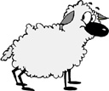

#### LITTLE BUDDY LAMB PROJECT - 2025

## AGES 5 – 7 YEARS

As a member of the 4-H Market Livestock Little Buddy Lamb Project, you are required to submit your records as part of an educational notebook project in order to show your animal at the Oceana County Fair. This notebook must be shown to the Oceana County 4-H Market Livestock Committee’s Weighmaster at the time of weigh-in and then entered by you in the Educational Notebook Division of the Oceana County Fair on Entry Day.

## AGE _________

The age you enter depends on how old you are on or will be on January 1, 2025

**NUMBER OF YEARS IN PROJECT** ________

Use this sheet as the first page of your project record book. Fill it out completely.

**Please print or type neatly.**

NAME _________________________________________________________________

4-H CLUB _______________________________________________________________

BREED _________________________________________________________________

LAMB’S NAME ___________________________________________________________

# NAME OF BIG BUDDY ____________________________________________________

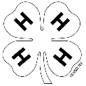

**JUDGE’S SCORE/COMMENT SHEET**

**(PLEASE DO NOT REMOVE, PLACE THIS SHEET IN SHEET PROTECTOR OR GLUE TO COVER). This sheet must be keep free to the judge to write their comments.**

This sheet should help each 4-H’er understand their ribbon placing.

A. **Specific educational value or worth**

___ All questions were answered completely

___ All calculations were correct

___ Calculations were incorrect

___ Questions were not answered (missed questions)

B. **Notebook contains all project records**

___ Notebook contained all project records and were fully completed

___ Notebook contained additional project related information (research

materials etc.)

___ Project records were incomplete

___There was no additional project related information

C. **Accuracy, neatness and general appearance**

___Notebook was neat in appearance (typed/hand printed)

___Notebook pages were clean and stain free

___Notebook pages were in order and complete

___Notebook was difficult to read and messy

__Notebook had wrinkled and stained pages

Other Comments: ______________________________________________________

____________________________________________________________________

**__________________________________________________________________**

# **LITTLE BUDDY LAMB NOTEBOOK**

**TABLE OF CONTENTS**

*Please keep your notebook in Table of Contents order.*

GENERAL GUIDELINE INFORMATON

ABOUT YOUR LAMB

JOURNAL OF CARE

PROJECT INFORMATION

SPECIFIC PROJECT KNOWLEDGE

Lamb Parts

YOUR PROJECT INFORMATION

a. My 4-H Project

b. 4-H Knowledge

6) PICTURES OF YOUR PROJECT (1 page)

7) CLUB POINT SHEET

APPENDIXES (OPTIONAL):

PICTURES OF YOUR PROJECT (additional pictures)

FEED INFORMATION (example: feed labels)

ADDITIONAL INFORMATION ABOUT YOUR PROJECT

Information you found in reference materials

Worksheets done with your 4-H Club

Information you located off the internet

Information from your feed representative

Any other information

*\* Include notes as to why you researched this information and*

*found it valuable, link it to your project if possible.*

Notebook Resources:

4-H Skills for Life Animal Series – Sheep 1, 2 & 3

(All lamb leaders have a set of these booklets. There is also a set available on a check-out system at the

MSU Extension Office)

Your Sheep – A Kid’s Guide to Raising & Showing (National 4-H Supply)

Lamb Showmanship Handout – MSU Extension

Kansas State 4-H Online Website

**\*\*NOTE THIS AGE GROUP DOES NOT REQUIRE POTENTIAL BUYERS. IF YOU INCLUDE THOSE, PLEASE ADD IT TO THE BACK SECTION OF YOUR BOOK.**

2025-Little Buddy Lamb Notebook (5-7) Page 1

This record book is part of your 4-H Market Lamb Project. By keeping records up-to-date you will be able to see how much progress you make as you set goals and work to accomplish them. Write neatly and clearly. Feel free to add extra pages.

**FAIR ENTRY RULES**

If you are between the ages of 5 and 7 years old and elect to participate in a 4-H class at the Oceana County Fair you will be awarded a participation ribbon for your efforts.

In order to compete for an “A”, “B” or “C” Ribbon you will have to enter you record book in the “Open Educational Notebook Class”.

If you have questions, please contact your leader or the MSU Extension Office as fair approaches.

#### PROJECT PICTURES

Pictures are a required part of this notebook. Taking pictures of your project animal throughout the project will indicate how your animal has grown and developed. Add pictures to your notebook on a separate piece of paper.

#### SCORING CRITERIA

The following breakdown will be used during the judging process of all market livestock notebooks.

A. Specific educational value or worth **30%**

B. Creative way of showing what has been learned **10%**

C. Notebook contains all project records **50%**

D. Accuracy, neatness and general appearance **10%**

**The Oceana County 4-H Market Livestock Committee encourages 4-H Leader and parent assistance with your project and project notebook**. If you should have any questions, please contact the MSU Extension Office.

I, ____________________________ assisted ________________________ in

Parent/Leader/Adult Name 4-Her’s Name

understanding the questions and writing the answers. All answers are those of the 4-Her.

____________________________________

Signature of person helping with notebook

***If*** written help was needed

### 2025- Little Buddy Lamb Notebook (5-7) Page 2

**ABOUT YOUR LAMB**

My Lamb’s name is: ___________________________________________

My Lamb’s breed is: ___________________________________________

What color is your Lamb? ______________________________________

My Lamb’s favorite thing to do is? ________________________________

**My Lamb is a** (circle one) **Wether** (boy lamb) **Ewe** (girl lamb)

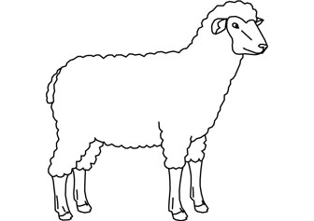

### 2025- Little Buddy Lamb Notebook (5-7) Page 3

**ANIMAL CARE AND MANAGEMENT- JOURNAL OF CARE**

Your project requires regular care and management.

Include the following:

* Walking and working with your animal
* Feeding and watering practices
* Grooming (clipping, toenail trimming, washing, etc.)
* Health practices and medicines (vaccinations, etc.)
* General Management (cleaning living area, feed pans, etc.)

|  |
| --- |
| **Daily- Things done once or twice a day** |
|  |
| **Weekly- Things done once or twice a week** |
|  |
| **Monthly- Things done once a month** |
|  |
| **Yearly- Things done one time or occasionally throughout the year** |
|  |

*My little buddy helped me with the care and training of our project animal.*

Signature of Big Buddy:___________________________________ Date: ____________

2025- Little Buddy Lamb Record Book (5-7) Page 4

**PROJECT INFORMATION**

The start of the project will be the date the 4-Her placed the animal on feed, not any later than June 1st of the current year. The end of the project will be weigh-in day at the Fair.

Project Start Date June 1, 2025 Project End Date ________________

Fair haul in day

What month was your lamb born? _________________________

Please complete the following chart about your project. Have your big buddy help you.

|  |  |  |  |  |  |  |  |
| --- | --- | --- | --- | --- | --- | --- | --- |
| Ear Tag  Number | Breed | Gender | Date of Purchase | Price or Value | Estimated  Starting Weight | Ending Weight | Total Pounds Gained |
|  |  |  |  |  |  |  |  |

**Note: Total pounds gained = ending weight – starting weight**

**MARKETING**

One of the most important parts of any market animal project is marketing. This may include writing letters and talking to prospective buyers. Color in the face, a smiling face is a good action, a frowning face is a bad action. (see the example)

**Good Marketing Practice Poor Marketing Practice**









































Send a picture to your potential buyers

Send a reminder to attend the auction

Let an adult talk to the buyer instead of you talking to them

Know the breed of your animal, if asked

Only ask family members to be potential buyers

Make sure to visit your previous buyers

Only thank those who agree to be listed as a potential buyer

Insult competitors

### 2025- Little Buddy Lamb Notebook (5-7) Page 5

**LAMB PARTS**- Color the lamb parts

Breast- Orange Fore shank- Green Neck- Black

Face- Blue Leg- Purple Rack- Pink

Flank- Red Loin- Yellow Shoulder- Brown

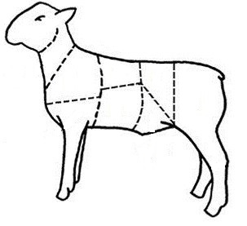

2025- Little Buddy Lamb Notebook (5-7) Page 6

**YOUR PROJECT**

Please answer the following questions to the best of your ability.

1. What did you have the most fun doing with your project?

______________________________________________________________________________________

______________________________________________________________________________________

______________________________________________________­­­­­­­­________________________________

______________________________________________________________________________________

2. What was the hardest part of your project?

______________________________________________________________________

______________________________________________________________________

_____________________________________________________________________________________

_____________________________________________________________________________________

3. Will you do a lamb project again?

____________________________________________________________________________________

Why or why not?

_____­­­­­­_____________________________________________________________­­­­­­___________________­­­­­­

­­­­­­­­

____________________________________________________________________________________

_____________________________________________________________________________________

_____________________________________________________________________________________

2025- Little Buddy Lamb Notebook (5-7) Page 7

**4-H KNOWLEDGE**

**The 4-H Pledge**- *Draw a line to the picture that fills in the blank* (see the example)

***I pledge…***

HANDS

HEALTH

HEAD

HEART

WORLD

COUNTRY

CLUB

COMMUNITY

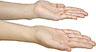









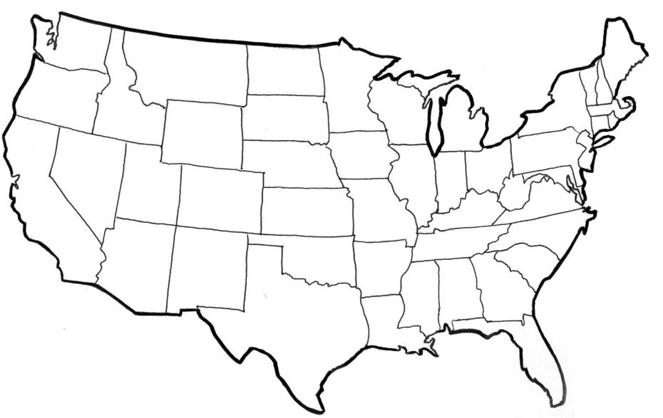

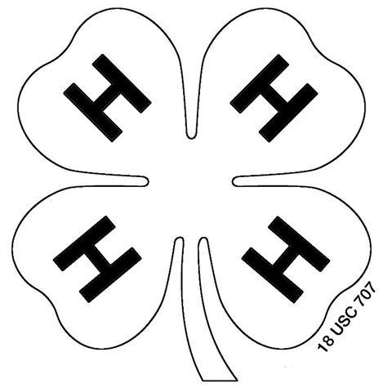



My ____________ to clearer thinking,

My ____________ to greater loyalty,

My ____________ to larger service, and

My _____________ to better living,

for my ____________________,

my _______________________,

my _______________________,

and my ____________________.

###### 

2025- Little Buddy Lamb Record Book (5-7) PAGE 8

**YOUR PROJECT PICTURES**

(Please use this page for your project pictures and tell anything special, that you might want the judge to know, about you and your project animal.

**CLUB POINTS**

**MARKET LIVESTOCK ATTENDANCE RECORD- ALL AGES MUST COMPLETED.**

Please note: This form must be included with your record notebook and turned into the weigh master on entry day of the fair. You need to accumulate **Six (6)** club meetings to be considered as completing your project. Non-club points are optional for this age group and if included should be on separate sheet (available at MSU Extension) and included in the back of your book.

|  |  |  |  |  |
| --- | --- | --- | --- | --- |
| **MEETING NAME** | **LOCATION** | **DATE** | **POINTS** | **SIGNATURE OF LEADER, SUPERINTENDENT OR MSU STAFF** |
|  |  |  |  |  |
|  |  |  |  |  |
|  |  |  |  |  |
|  |  |  |  |  |
|  |  |  |  |  |
|  |  |  |  |  |
|  |  |  |  |  |
|  |  |  |  |  |
|  |  |  |  |  |
|  |  |  |  |  |
|  |  |  |  |  |